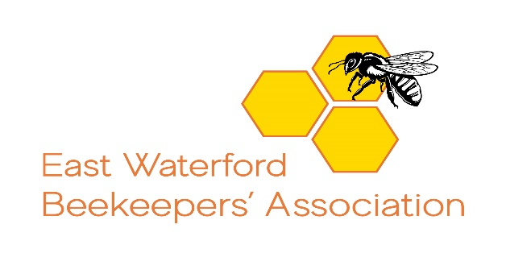

Introduction to Beekeeping Course

Application Form 2021

Name:________________________________________

Address:__________________________________________________________________

____________________________________________________________________

County:______________________________________

Eircode:_________________________________________________

Email:___________________________________________________

Phone No:_______________________________________________

Course Type Selected : Lectures Only □ or Lectures and Apiary Demonstrations □

Recommended Book for the Course: The Haynes Bee Manual by Claire and Adrian Waring

Course Fees:
Lectures only: €60 (Lectures x 6 (inclusive of practical online demonstrations).
Lectures and Apiary Demonstrations: €110

Lecture Dates: Tues 2, 9, 16, 23, 30 March and 6 April from 7-8:30pm online via Zoom

The fee of €110 covers
- Lectures x 6 (inclusive of practical online demonstrations).
- Visits to the Association Apiary x 4 for actual demonstrations in Apri/lMay/June.Covid permitting
- Membership of EWBA and the Federation of Irish Beekeepers until 31/12/2021
- A copy of An Beachaire (the Irish Beekeeper’s Magazine) monthly until 31/12/2021.
- Third Party Insurance for your beekeeping.
- Eligibility to participate in EWBA & FIBKA education and Certified Exam Programme.
Fees to be paid on line through the Association Bank Account details of which will be sent on receipt of your Application.
The link to join the lectures will also be sent on payment of your fee.
Website: www.waterfordbees.com, email:waterfordbees@gmail.com, facebook: East Waterford Beekeepers Association

